Assignment Report

Task 1: Food Delivery Homepage Wireframe
The wireframe below illustrates the homepage layout for a fictional food delivery application including header, search, categories, featured restaurants, offers, popular dishes, and footer.
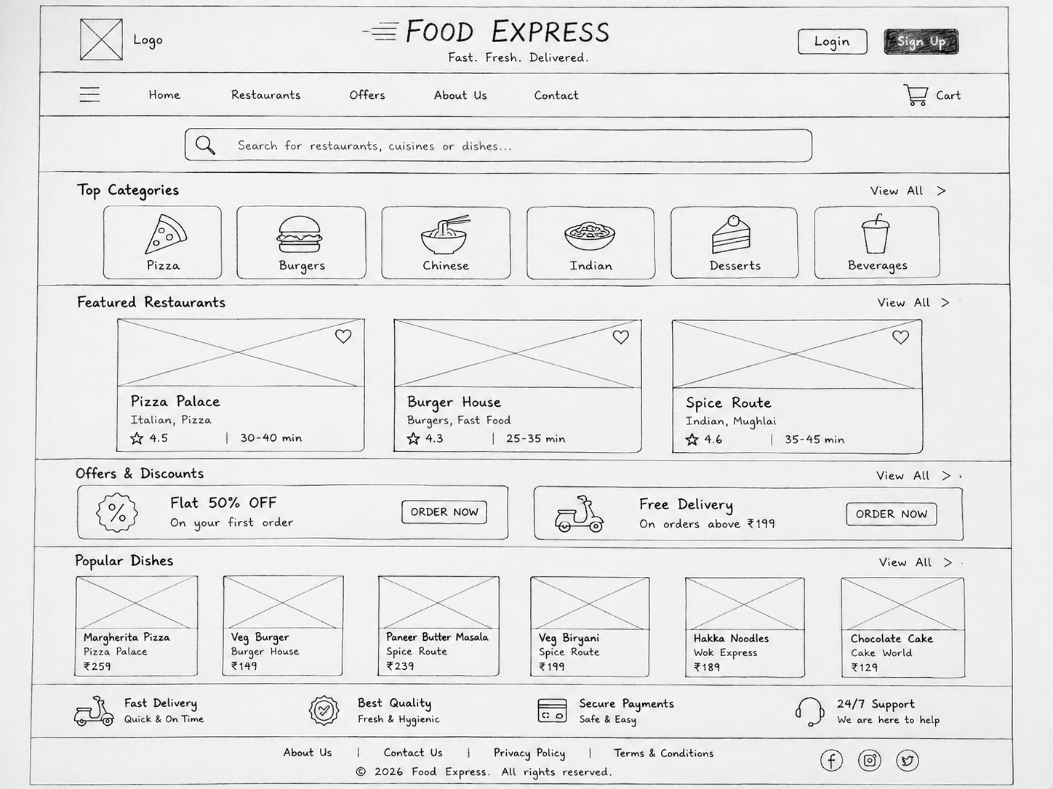

Task 2: HTML Structure (Music Streaming App)
Create a header, navigation bar, featured playlists section, and footer using HTML only (code submitted separately).

Task 3: Five Above-the-Fold Elements
Element | Importance
Logo | Identifies the brand.
Search Bar | Quickly find products.
Navigation | Easy browsing.
Banner | Highlights offers.
Login/Cart | Fast account and cart access.

Task 4: App Observation (Swiggy)
First three sections: Search Bar, Food Categories, Popular Restaurants.
The order helps users quickly search, browse cuisines, and discover restaurants, improving usability and engagement.

